HOW TO PAY ONLINE
- Visit the Issaquah School District Website (http://issaquah.wednet.edu).
- Click on the “Pay Online” link.
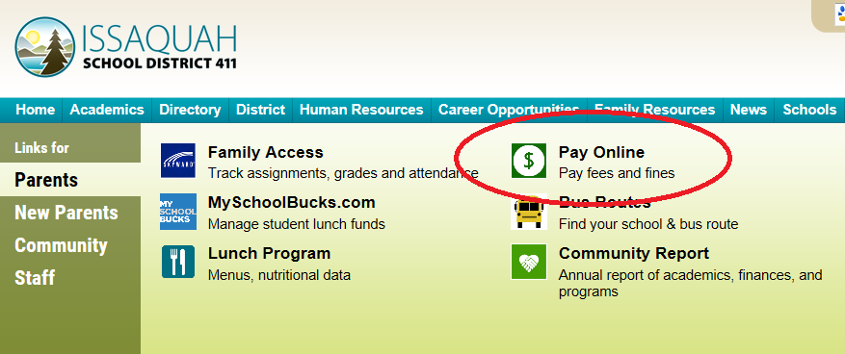
- To log-in, the user name is the same as your Family Access username (all uppercase), and the password is the parent’s last name (first letter uppercase, rest lowercase; i.e. Smith).
Questions? Contact Cyndi Thompson (thompsonc@issaquah.wednet.edu)

- Follow the directions to complete your payment.
You do NOT need to print a receipt, but please mark on the permission slip that you have paid online (upper right hand corner).

